

9B19A015

all or nothing brewhouse: MANAGING BEER BRANDS

Ken Mark wrote this case under the supervision of Professor Miranda Goode solely to provide material for class discussion. The authors do not intend to illustrate either effective or ineffective handling of a managerial situation. The authors may have disguised certain names and other identifying information to protect confidentiality.

This publication may not be transmitted, photocopied, digitized, or otherwise reproduced in any form or by any means without the permission of the copyright holder. Reproduction of this material is not covered under authorization by any reproduction rights organization. To order copies or request permission to reproduce materials, contact Ivey Publishing, Ivey Business School, Western University, London, Ontario, Canada, N6G 0N1; (t) 519.661.3208; (e) cases@ivey.ca; www.iveycases.com. Our goal is to publish materials of the highest quality; submit any errata to publishcases@ivey.ca. i1v2e5y5pubs

Copyright © 2019, Ivey Business School Foundation Version: 2019-04-12

We grew up learning to cheer on the underdog because we see ourselves in them.

Eric and Jeff Dornan

“How should we manage the beer brands we have?” asked Eric Dornan, co-founder of All or Nothing Brewhouse in Oshawa, Ontario. Eric and his brother Jeff had purchased Trafalgar Ales, Meads and Distillery (Trafalgar) in July 2016. By that time, the Dornan brothers had already launched their own brand of wheat beer—All or Nothing Hopfenweisse (see Exhibits 1 and 2). The Hopfenweisse product was available at over 500 Liquor Control Board of Ontario (LCBO) and 300 The Beer Store locations, and was selling well. Trafalgar had a wide variety of beers in production, as the previous owner had pursued a strategy of creating unique and small batches of beer, refreshing the lineup over the years.

In September 2016, the Dornans were interested in devising a brand strategy for their entire brewery. They could continue to maintain the strategy of having a constellation of brands, each with its own distinctive identity. Or they could focus on a few core brands—two or three identities, with flanker brands under each banner. They could also pursue a single brand identity, putting forth either All or Nothing Brewhouse or Trafalgar as the umbrella brand.

**The Beer Industry**

In 2016, there were 775 brewers in Canada, up 20 per cent from 644 brewers in 2015. Per capita beer consumption in Canada was 77.1 litres, down 2.9 per cent from 2015. Domestic sales volumes had declined to 22.3 hectolitres (hl)[1] in 2016 from 22.8 hl in 2015.[2]

The beer industry in Ontario was dominated by large international brewers such as Anheuser-Busch InBev and Molson Coors Brewing Company. From 2012 to 2016, sales of domestic beer in Ontario dropped from 6,727,041 hl to 6,426,110 hl. During the same period, sales of imported beer rose from 1,319,887 hl to 1,583,682 hl. Per capita consumption of beer in Ontario fell from 76.5 litres in 2012 to 72.1 litres in 2016.[3]

There were about 242 operating breweries in Ontario, including 72 contract brewers and over 100 craft breweries in the planning or start-up stage. There had been unprecedented growth in the number of brewers over the years; in 2012, the province had just 90 breweries.

Ontario craft beer was forecasted to reach CA$370 million[4] in sales, with volume at 608,000 hl, accounting for 7.6 per cent of the Ontario market for beer by the end of 2017. For perspective, sales from craft breweries in Ontario were $240 million in 2015.

**Distribution**

Craft brews, especially in the premium segment, were differentiated by brand positioning and taste. Craft brews were sold to customers through restaurants and bars, and in retail outlets such as The Beer Store (450 locations) and the LCBO (651 stores).

A typical 473-millilitre can of a big brand beer such as Budweiser retailed for $2.55 at the LCBO, and a craft brewer’s beer—Creemore Springs Premium Lager, for example—retailed for $3.10.

Molson Coors Brewing Company alone had sales of $268 million in Canada in 2015, more than the entire Ontario craft brewery industry combined.[5] Beer brands, both international and craft, competed for access to restaurants and the retail trade.

In restaurants, getting beers “listed” and available on tap often meant providing incentives to list, including a free case or two for each order, customized pouring taps, and other decorative and beer serving accessories such as signs or beer glasses. While there were about 7,500 licensed and non-licensed nightclubs, bars, and restaurants in Toronto, there were about 200 high-volume establishments that sold beer in large quantities.[6]

Selling beer to retailers such as the LCBO, The Beer Store, and grocery stores meant meeting with buyers to present potential new products.

While there was space dedicated to craft brews in all three outlets, the most significant risk the buyer faced was saying yes to a product that did not have high selling potential. For a small brand, generating awareness of its product was always a challenge, and there was a risk that the beer consumer would simply bypass a new brand in favour of other, more familiar or recognizable brands. Product that had a low chance of meeting a minimum turnover target—say, one case of 24 bottles a week per store—was not generally approved by buyers.

In 2015, Ontario relaxed its alcohol distribution restrictions, allowing select grocery stores to carry beer and wine. Important changes were implemented in 2015 to support craft breweries, with the government mandating that at least 20 per cent of shelf space in The Beer Store and grocery stores be allocated to local craft brews. There were 300 grocery stores allowed to carry alcohol in 2016, and this figure was expected to rise to 450 by 2019.[7]

**Consumers**

Given that craft brews were a small percentage of the market, Ontario craft brewers tended to market their product by highlighting its unique taste or origin credentials. There was very little competitive positioning touting one craft beer’s benefits over another’s. All the ingredients necessary for brewing beer were widely available commercially, and there were no proprietary or “secret” formulations that could not be replicated.

Consumers in Ontario had a wide variety of domestic, big brand, and craft brews from which to choose. There was a sense, among craft brewers, that there were three general segments of consumers: the consumer loyal to domestic or U.S. beer brands who rarely sampled anything else, the consumer with no set preferences between domestic or craft brews, and the craft brew consumer who was interested in sampling a variety of craft brands. On one hand, the tendency for fans of craft brews to try new flavours and brands meant there would always be a place for new brands and products. On the other hand, craft brew brands could not count on, generally speaking, a large cohort of loyal consumers who would only seek out and consume that brand’s products.

Craft Brewers

Starting a craft brew brand could cost as little as $250,000, if entrepreneurs wanted to pick off-the-shelf packaging and design a limited run of labels. If they worked with a master brewer and a contract brewery, they could develop a beer that had a unique flavour profile and pay for an initial run of perhaps 10,000 units. In contrast, starting a brewery from scratch cost about $2 million—for renting space, buying equipment, and the working capital required to hire staff to brew and package the beer.

The key challenge of growing a brand with contract brewing as part of the operation was the limited amount of control the brand had over timelines and margins. Ceding control over production to a contract brewery meant that the brand was beholden to the contractor’s timelines. Given that contract breweries generally had their own brands, production priority was given to the contractor’s brands. In addition, the fee charged to outsiders to brew and package beer meant that gross margins were slim for the new craft brew brand: 10 per cent per bottle versus 25 per cent for a typical end-to-end craft brewery.

**All or Nothing Brewhouse**

According to Eric, the Dornans had “entrepreneurship in our DNA.” Both their paternal and maternal grandfathers had worked in business or had run their own businesses. Growing up, the brothers worked for their father’s small family business—a supplier to retailers—and managed their personal and school schedules around work. As part of their job, they were asked to go to a Home Depot store to reface the tile feature in the Tile section. Redoing that feature meant hauling hundreds of pounds of tile off of the wall. It took them until the early hours of the morning to redo the feature. They then had to do the same for several other Home Depot stores in Ontario. They were exhausted after each reset but nevertheless had to attend morning classes at Seneca College the next day. They had little sympathy, they recalled, for classmates complaining about the challenges they were facing in managing school work. “It was quite surreal to hear our classmates complaining about what seemed like a luxurious existence to me,” recalled Eric.

In 2010, when the brothers were in their late teens, they co-founded Premier Products with their father, Ron. Premier Products was another manufacturer’s representative agency, representing global manufacturers in their bids to sell their wares at places such as The Home Depot.

In 2014, the brothers decided to seize an opportunity to move into the beer and liquor industry. They recalled, “We saw an industry where craft brewers were emerging in popularity, and there were these giant multinationals. There was almost nobody in-between, with the exception of Steam Whistle [Brewing], Mill Street [Brewery], and, at that time, Creemore Springs. You were either ‘craft’ and small, or . . . a large conglomerate. We saw an opportunity to enter the market.”

To fund their entry into the craft brew industry, the Dornan brothers drew on their savings. They had saved their money from Premier Products and used it to buy houses in Whitby, Ontario when they were 22 years old, and by the time they were 30, in 2016, the houses had each increased in value from $200,000 to $800,000. In mid-2014, the brothers gathered capital of $50,000 each to start a contract brewer called Underdog’s Brewhouse (UB), using Railway City Brewing Co. as the brewer. A contract brewer outsourced production of beer to another company that had brewing facilities.

Underdog’s Brewhouse

“We wanted a name that highlighted the ‘brand’ we wanted to build. We’re the underdog and, naturally, we wanted to call our brewery ‘Underdog’s Brewhouse,’” Jeff explained. “The first thing we did was to do a thorough search of trademarks. At the time, we found nothing with that name or combination of names.”

After UB was established and about $100,000 worth of packaging, promotional, and trade marketing materials ordered, the brothers received a “cease and desist” letter from a competing brewer. In parallel, the brothers tried to build their UB brand by attending music festivals and other outdoor events. They sold beer, introducing their products to consumers. “Getting involved in these festival promotions seems like a very attractive thing to do,” said Jeff. “It isn’t, from a margin perspective. At best, one can look at it as a break-even proposition. But it does wonders for getting your brand name more well-known. We did very well from these promotions.”

In the summer of 2015, the company launched its first beer product in the LCBO and The Beer Store. By this time, UB had been rebranded All or Nothing Brewhouse, a change the brothers made in January 2015. (See Exhibits 1 and 2 for pictures of Eric and Jeff and their Hopfenweisse beer brand.)

**Developing a New Brand**

Eric spoke about how he and his brother created a new brand from scratch:

We chose to classify our very first beer as a “Hopfenweisse,” which is a German word, as we knew it would be a conversation starter, and it’s fun to try to pronounce it so people remember it versus calling it a “wheat ale” or a “hoppy wheat.”

We chose yellow because, at that time, no one had that tint as the dominant colour in their packaging. We took inspiration from Steam Whistle in the sense that we wanted to be identified by a single colour. Through our research, we concluded that yellow was the easiest colour for the human eye to recognize and that our eyes are drawn to it first. Yellow also sells youthfulness and optimism.

We chose to create a David versus Goliath type of branding, as this had not been done yet but, in our industry, rings exceptionally true where the majors are all huge multinational conglomerates and then lots of “little guys.” We implemented an innovative box design from day one, which we marketed and [that we] attribute as a reason for our early success. The cardboard box included a cut-out design for “Cornelius,” the imaginary boxer whose image we use on our product. Around this design was a perforated edge to allow consumers to remove and assemble a small cardboard stand featuring Cornelius. When we visited our retailers, we found Cornelius cardboard stands in LCBO stores at their computers, in staff lockers, glued to doors that go into the back warehouse, etc. So it allowed us to stand out and be remembered as the yellow brand with two boxers at the very least.

As part of the branding, the Dornans created marketing materials and products that would support the brand’s character (see Exhibit 3). There were certain aspects of branding they decided not to pursue, as Jeff explained: “We actively chose not to identify with a sole region of Canada like 99 per cent of other breweries do, as we try to think larger and knew at some point our business would likely move for various reasons, but that the original place we started likely would not be where we end up.”

The Dornans promoted their Hopfenweisse beer by conducting taste tests at LCBO stores and by attending beer and music festivals, where with a travelling booth they sold beer to consumers. The cost of running taste tests at LCBO stores was about $450 a day. Taste testing beer at the LCBO generally boosted sales by about 25 cans a day, for just the one day they were sampling in the store. The cost to attend a three-day festival was about $3,000, and the brothers typically sold about the same amount in beer if the weather was good. The net cost of attending a three-day festival after accounting for gross margins from the sale of beer was about $750. There were about 30 festivals in Ontario, and each drew about 4,000 people over the three days. Once the brand was launched, the brothers turned their attention to Trafalgar’s stable of brands.

Devising a Brand Strategy

The Dornans reviewed the stable of brands over which they had taken ownership when they bought Trafalgar, a brewery that had been in production for 15 years. They noted that Trafalgar had started in the 1990s, when there were only 10–15 craft breweries in Ontario competing for market share. For the first 15 years of the brewery’s existence, the demand for craft beers was driven by the government’s intent to support local breweries. To further this strategy, the LCBO gave encouragement to local brewers, allowing breweries such as Trafalgar to submit a new stock-keeping unit (SKU) for listing every quarter. By 2012, however, the number of breweries had grown rapidly and the battle for shelf space had become much more competitive. By 2015, Trafalgar was managing a selection of about six SKUs at the LCBO and The Beer Store (see Exhibit 4). Trafalgar had other SKUs that were sold onsite, through both its storefront at the front of the brewery and about 100 restaurants in Ontario concentrated around the Greater Toronto Area. Trafalgar’s storefront was about 300 square feet in size and sold draft and retail-packaged beer to walk-in consumers. There was a restaurant on site—owned by another entrepreneur who had leased the space from Trafalgar—that served pub food. People who visited Trafalgar could arrange for tours of the brewery (see Exhibit 6). Eric offered details about the economics of brewing small-batch beer:

Let’s take this SKU, for example: “Black Creek Rifleman’s Rations Brown Ale—500-millilitre brown bottle.” Here are the hard direct costs incurred. Brown glass: $0.45; bottle cap: $0.05; paper label/glue: $0.09; cardboard (12-pack): $1.75 (or $0.15 per bottle); beer: $0.25; taxes: $0.20. This beer would retail at the LCBO for about $3.95 a bottle and the producer—Trafalgar—would get paid $2.75. From the contribution we’d have to pay overhead, labour, and freight costs, a total of about $600,000 a year. This does not include paying for indirect costs such as sales, general and administrative, which is another $200,000 a year.

The Dornans looked at the financial data and the brand information of the products they owned. They wondered what their brand strategy should be for 2017 and beyond (see Exhibits 7 and 8).

Exhibit 1: Eric and Jeff Dornan

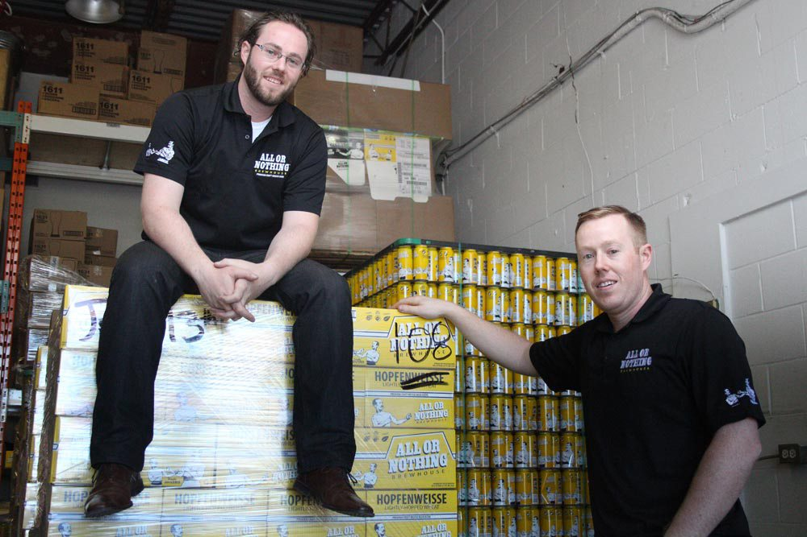

**Eric and Jeff**

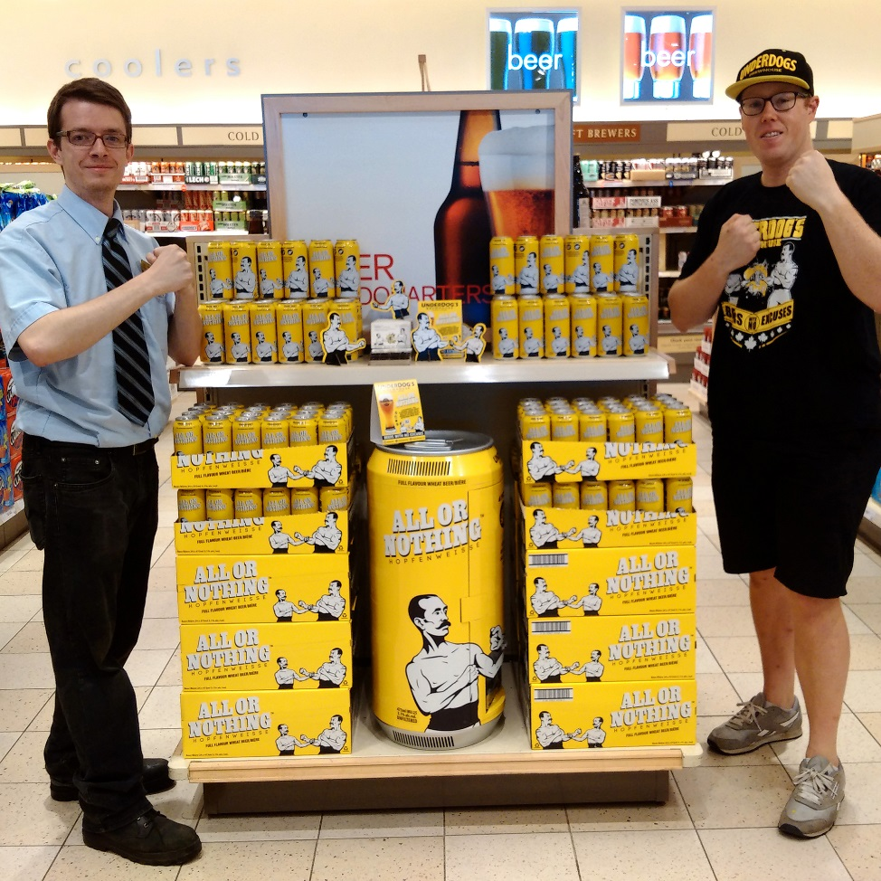

**LCBO Store Manager with Jeff**

Note: LCBO = Liquor Control Board of Ontario.

Source: Company documents.

Exhibit 2: All or Nothing Brewhouse—Hopfenweisse

|  |  |
| --- | --- |
| http://allornothing.beer/wp-content/uploads/2017/05/AON-Hopfenweisse-can-Smallest.png | All or Nothing Hopfenweisse  5.1% abv - 473 ml - 25 IBU - $2.95  SERVING TEMPERATURE: 4°−6°C/36°−46°F  GLASSWARE: Tall Fluted Weizen Glass—Pick one up at our online store!  Distribution:  Loblaws Brewery Bottleshop The Beer Store LCBO  A lightly-hopped, highly sessionable wheat beer, All or Nothing is like nothing you’ve seen before. Golden in colour, with a sparkling foamy head, the first sniff reveals notes of banana and bubblegum. Dig a little deeper and you’ll find hints of tropical fruit and a touch of citrus. When you finally bring that glass to your lips, you’ll be delighted by how the sweet and refreshing fruitiness is followed by more assertive tropical hops, creating a delightful hybrid of Hefeweizen and west-coast Pale Ale flavours. Unlike some other wheat beers, All or Nothing is brewed without added sugars or flavours. Using 3 types of malt and 4 varieties of hops, we’ve crafted a beer that is complex yet approachable, refreshing yet bold, and always delicious. Try us today, we think you’ll agree! |

Note: abv = alcohol by volume; ml = millilitres; IBU = International Bitterness Units; °C = degrees Celsius; °F = degrees Fahrenheit.

Source: Company documents.

Exhibit 3: All or Nothing brewhouse—Marketing Materials

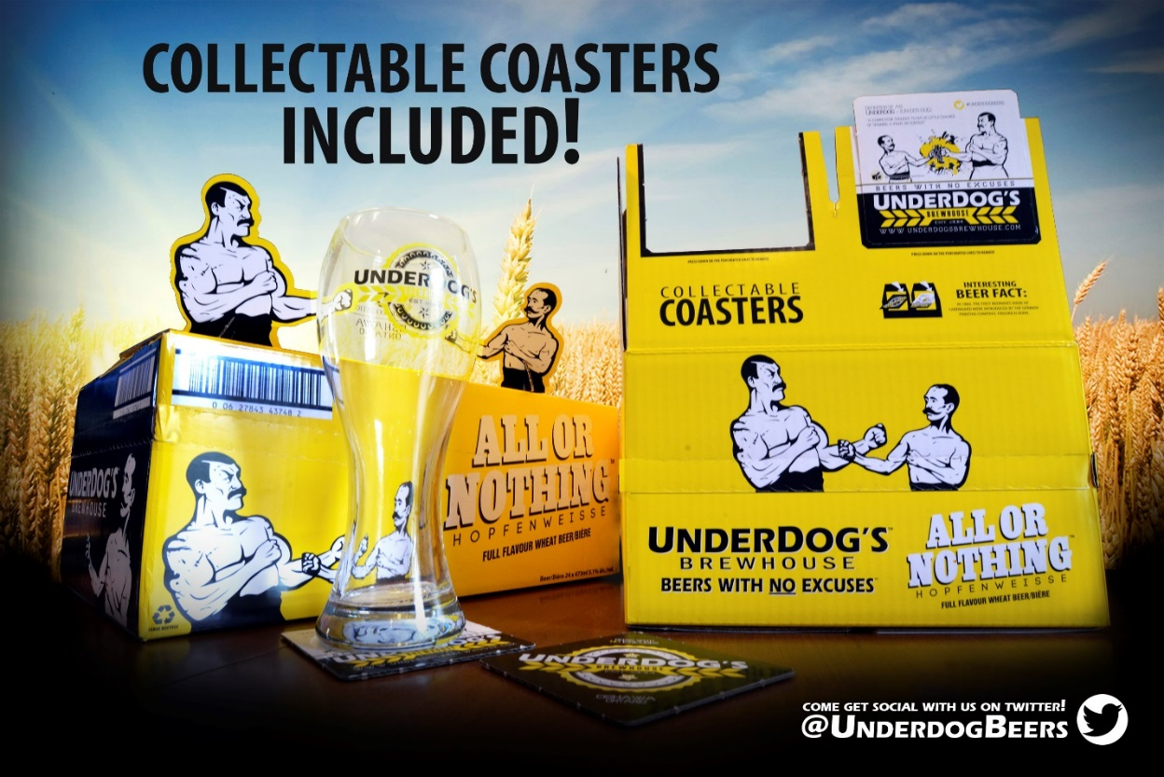

Exhibit 3 (continued)

|  |  |
| --- | --- |
|  |  |

Source: Company documents.

Exhibit 4: Trafalgar and All or Nothing brewhouses’s Assortment at the LCBO

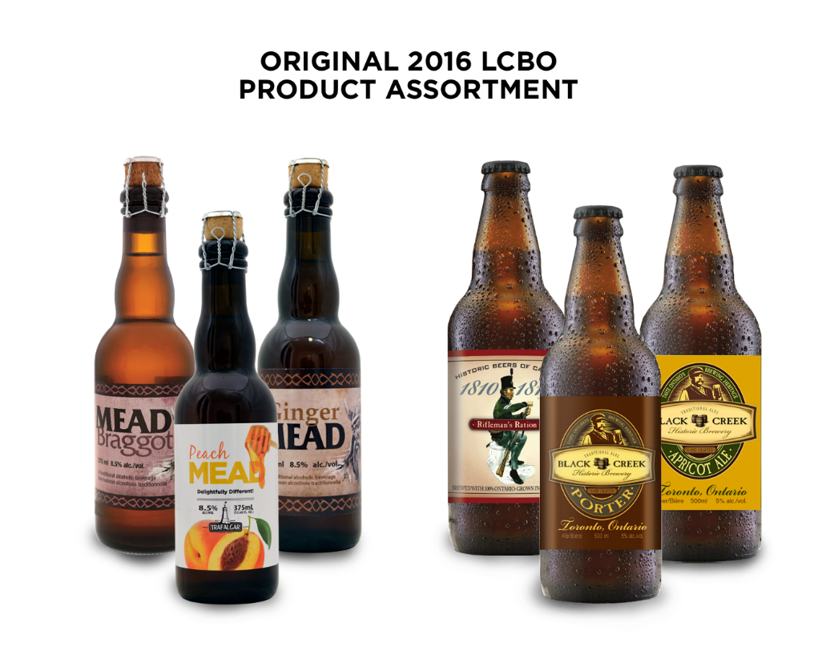

Note: LCBO = Liquor Control Board of Ontario.

Source: Company documents.

Exhibit 5: Trafalgar and All or Nothing brewhouse—Various SKUs

|  |  |
| --- | --- |
|  |  |
|  |  |
|  |  |

Note: SKU = stock keeping unit.

Source: Company documents.

Exhibit 6: Trafalgar Brewery—Brewery Store, circa 2015

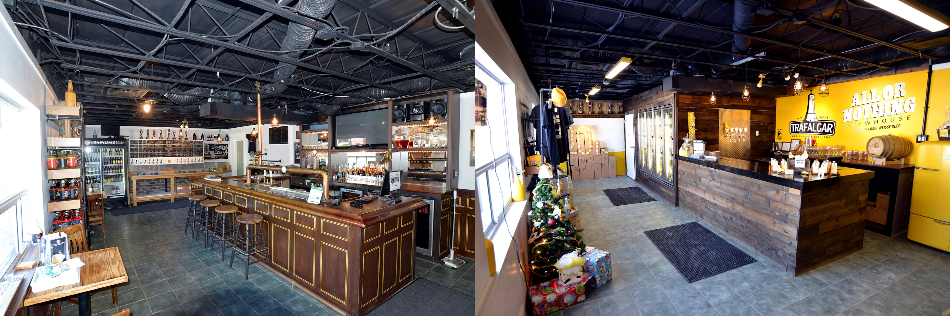

Source: Company documents.

Exhibit 7: Trafalgar and All or Nothing brewhouse—Selected Financials (CA$)

|  |  |  |  |  |
| --- | --- | --- | --- | --- |
| **Product** | **Revenues per SKU, Last 12 Months** | **Contribution per SKU, Last 12 Months** | **Revenues per SKU, Last 12 Months, as a Percentage of Total Sales** | **Contribution per SKU, Last 12 Months, as a Percentage of Total Contribution** |
| Black Creek Rifleman’s Rations | $82,500 | $46,800 | 7.7% | 7.7% |
| Black Creek Porter | $75,900 | $43,056 | 7.1% | 7.1% |
| Black Creek Apricot Ale | $23,100 | $13,104 | 2.1% | 2.2% |
| Irish Style Brown Ale | $56,100 | $31,824 | 5.2% | 5.2% |
| Red Hill Mild | $33,000 | $18,720 | 3.1% | 3.1% |
| Trafalgar Peach Mead | $66,000 | $37,440 | 6.1% | 6.2% |
| Mead Braggot | $62,700 | $35,568 | 5.8% | 5.9% |
| Ginger Mead | $56,100 | $31,824 | 5.2% | 5.2% |
| Northern Harvest Ale | $51,300 | $24,168 | 4.8% | 4.0% |
| Brasserie des Quatre Lunes—Saison d’Hiver | $36,300 | $20,592 | 3.4% | 3.4% |
| Brasserie des Quatre Lunes—Saison Automme | $33,000 | $18,720 | 3.1% | 3.1% |
| Smoked Oatmeal Stout | $29,700 | $16,848 | 2.8% | 2.8% |
| Old Mill Old Stout—Craft Brewer | $10,800 | $5,088 | 1.0% | 0.8% |
| Maple Leaf Lager | $23,100 | $13,104 | 2.1% | 2.2% |
| Honey IPA | $62,700 | $35,568 | 5.8% | 5.9% |
| Critical Mass—(14% Alcohol Beer) | $10,800 | $5,088 | 1.0% | 0.8% |
| Historic Beers of Canada—Dray Horse Ale | $23,100 | $13,104 | 2.1% | 2.2% |
| Historic Beers of Canada—Montgomery’s Courage | $23,100 | $13,104 | 2.1% | 2.2% |
| Paddy's Cream Ale | $16,500 | $9,360 | 1.5% | 1.5% |

EXHIBIT 7 (CONTINUED)

|  |  |  |  |  |
| --- | --- | --- | --- | --- |
| **Product** | **Revenues per SKU, Last 12 Months** | **Contribution per SKU, Last 12 Months** | **Revenues per SKU, Last 12 Months, as a Percentage of Total Sales** | **Contribution per SKU, Last 12 Months, as a Percentage of Total Contribution** |
|  | $775,800 | $433,080 | 72.1% | 71.3% |
| All or Nothing—Hopfenweisse (Canada)* | $300,000 | $174,000 | 27.9% | 28.7% |
| **Total** | **$1,075,800** | **$607,080** |  |  |
|  |  |  |  |  |

Note: SKU = stock keeping unit; IPA = India pale ale; * launched in Summer 2015 and listed in the Liquor Control Board of Ontario in 2015.

Source: Company documents.

Exhibit 8: Trafalgar and All or Nothing brewhouse—Beer Brands

|  |  |  |  |
| --- | --- | --- | --- |
| **As at December 31, 2016** | | | |
| **Product** | **Type** | **Product Characteristics** | **Target Consumer** |
| Black Creek Rifleman’s Rations | Dark Ale | Rifleman’s Rations brings us back to the days when ales were issued to soldiers as part of their pay. It is brewed the traditional way in our historic location. | Craft beer enthusiasts; traditional ale drinkers; aged 25 and above |
| Black Creek Porter | Dark Ale | Black Creek Porter is a style of well-hopped dark beer, made from brown malt that was first developed in England and brought over by the early settlers. | Craft beer enthusiasts; traditional ale drinkers; aged 25 and above |
| Black Creek Apricot Ale | Dark Ale | A historic brew that has been revived, Apricot Ale is brewed in small batches. |  |
| Irish Style Brown Ale | Dark Ale | This flavour-packed brown ale with coffee, toffee, and roasted notes, is finished with a satisfying hoppy bitterness. | Traditional ale drinkers; aged 40 and above |

Exhibit 8 (continued)

|  |  |  |  |
| --- | --- | --- | --- |
| **Product** | **Type** | **Product Characteristics** | **Target Consumer** |
| Trafalgar Peach Mead | Mead | This honey-based drink is accented with peach flavours. | Consumers interested in trying traditional drinks other than beers, ales, and spirits; aged 25 and above |
| Mead Braggot | Mead | Mead Braggot (mead brewed with barley malt) is a historically accurate recipe brewed in a modern facility. It is made with premium Ontario-grown ingredients, including two row barley malt, and honey sourced less than an hour from the brewery. | Consumers interested in trying traditional drinks other than beers, ales, and spirits; aged 25 and above |
| Ginger Mead | Mead | Similar to Peach Mead, Ginger Mead is flavoured with ginger. | Consumers interested in trying traditional drinks other than beers, ales, and spirits; aged 25 and above |
| Northern Harvest Ale | Dark Ale | Northern Harvest Dark Ale is a herbed/spiced style beer. | Traditional ale drinkers; aged 40 and above |
| Brasserie des Quatre Lunes—Saison Automme | Dark Ale | Similar to Saison d'Hiver, this is a retro-style saison ale. | Craft beer enthusiasts; aged 25 and above |
| Smoked Oatmeal Stout | Dark Ale | Smoked Oatmeal Stout is a heavy beer with roasted barley, accompanied by a touch of dark brown sugar and malty flavours. | Traditional ale drinkers; aged 40 and above |
| Old Mill Old Stout—Craft Brewer | Dark Ale | Old Mill Old Stout is an Oatmeal Stout-style beer that uses oats in the mash for a smooth, rich taste. | Craft beer enthusiasts; traditional ale drinkers; aged 25 and above |
| Maple Leaf Lager | Lager | This pilsner-style beer is easy to drink, formerly branded as Old Mill Elora Grand Lager. | A broad range of consumers aged 18 and above, many of whom also drink Molson Canadian |
| Honey IPA | Pale Ale | This American-style beer is flavoured with honey. | A broad range of consumers aged 18 and above |
| Critical Mass—(14% Alcohol Beer) | Beer | Critical Mass is an unusually strong beer. | Specialty consumers interested in a strong beer |
| Historic Beers of Canada—Dray Horse Ale | Dark Ale | Dray Horse Ale represents the era of canal building from 1820 to 1829. It is a rich, robust ale suited for the fall and winter seasons. | Traditional ale drinkers and those interested in history; aged 40 and above |

EXHIBIT 8 (CONTINUED)

|  |  |  |  |
| --- | --- | --- | --- |
| Historic Beers of Canada—Montgomery’s Courage | Dark Ale | Montgomery’s Courage is named after a historic Yonge Street tavern. It uses a historic recipe. | Traditional ale drinkers and those interested in history; aged 40 and above |
| Paddy’s Cream Ale | Dark Ale | Paddy’s Cream Ale is brewed to be light and refreshing. | A broad range of consumers aged 18 and above |
| All or Nothing—Hopfenweisse (Canada)* | Wheat beer | Hopfenweisse is hazy and has a medium-amber colour with a foamy head; light aromas of sweet malt, toasted grain, coriander/clove spice, citrus peel, and herb with notes of pine, banana, and tropical fruit; lightly sweet, soft, rounded, flavours of grain, citrus, and herbal hops with notes of bread and candied fruit; and a clean, crisp, and refreshing finish. | Craft beer enthusiasts; a broad range of consumers aged 18 and above |
|  |  |  |  |

Note: IPA = India pale ale; * launched in Summer 2015 and listed in the Liquor Control Board of Ontario in 2015.

Source: Company documents.

1. 1 hectolitre = 100 litres.
2. “Industry Trends 2016,” Beer Canada, accessed January 3, 2018, <https://industry.beercanada.com/statistics>.
3. “Ontario,” Beer Canada, 2016, accessed January 3, 2018, https://industry.beercanada.com/statistics/ontario.
4. All dollar amounts are in Canadian dollars.
5. Quentin Casey, “Molson Coors Ushers in a New Era for Canada’s Oldest Brewery,” Financial Post, May 25, 2016, accessed January 3, 2018, http://business.financialpost.com/executive/c-suite/molson-coors-ushers-in-a-new-era-for-canadas-oldest-brewery.
6. “Number of Restaurants in Toronto,” City of Toronto, accessed January 3, 2018, www.toronto.ca/311/knowledgebase/kb/docs/articles/economic-development-and-culture/program-support/number-of-restaurants-in-toronto.html.
7. Ontario Craft Brewers, Industry Fact Sheet, accessed January 3, 2018, www.ontariocraftbrewers.com/pdf/media_IndustryFactSheet.pdf.